|  |
| --- |
| Circle Language Spec: Inheritance |

## Command Extension

When a base class defines a command, the derived class can add extra functionality to the existing command. The derived class can pre- or post-extend a command from the base class:

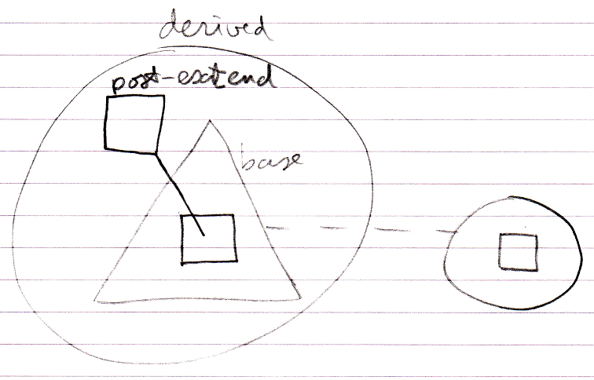

This pre- and post-extension happens by means of the already available system events explained in the *Events* chapter. The events are actually named Executing and Executed.

